HARROW COUNCIL

ADDENDUM

PLANNING COMMITTEE

DATE: 24th May 2023

1/01 | 2-4 Hindes Road, Harrow, HA1 1SJ – P/3833/22  Drainage details have been submitted and accepted by the Drainage team, as such:  Amend Recommendation A as follows:  RECOMMENDATION A  - Agree the reasons for approval as set out in this report, and  2) 1) Grant planning permission subject to authority being delegated to the Chief Planning Officer in consultation with the Director of Legal and Governance Services for the following:  Amend Recommendation B as follows:  RECOMMENDATION B  That if the outstanding drainage matters are not addressed to the satisfaction of the Local Planning Authority and the Section 106 Agreement is not completed by 24th September 2023, or as such extended period as may be agreed by the Chief Planning Officer, then it is recommended to delegate the decision to REFUSE planning permission to the Chief Planning Officer on the grounds that:  - In the absence of an adequate flood risk assessment and associated details fails to appropriately address the potential flood risk of the development, contrary to the National Planning Policy Framework (2021), policies SI12 and SI13 of The London Plan (2021), Core Strategy (2012) policy CS1, and policies DM9 and DM10 of the Harrow Development Management Polices Local Plan; and/or,  2) 1) The proposed development, in the absence of a Legal Agreement to provide appropriate improvements, benefits and monitoring that directly relate to the development, would fail to adequately mitigate the impact of the development on the wider area and provide for necessary physical infrastructural improvements arising directly from the development, contrary to the National Planning Policy Framework (2021), policies T3 and DF1 of The London Plan (2021), Core Strategy (2012) policy CS1, Harrow & Wealdstone Area Action Plan Policies AAP2, AAP4, AAP10, AAP13, AAP19 and AAP20, and policies DM1, DM43 and DM 50 of the Harrow Development Management Polices Local Plan and the Supplementary Planning Document: Planning Obligations & Affordable Housing (2013).  Insert the following under paragraph 4.4. within the ‘Internal Consultees’ section:  LBH Drainage  Comments dated 17/05/2023  We can confirm that the drainage strategy proposed is satisfactory and further details can be conditioned with our standard drainage conditions.  Updated paragraph 6.6.2 of the report as follows:  - The site is identified as a critical drainage area of Harrow and Hindes Road at the front of the site is within Surface Water Drainage Zone 3a, although no part of the site itself is within the flood zone. Notwithstanding, the Council’s Drainage officers have requested surface water discharge restriction details, calculation details and associated drawings which were provided during the determination of the application, and the drainage details were ultimately considered acceptable subject to standard conditions of consent. They have also requested details of emergency planning in the event of a flood on the highway and details of a safe means of escape for the future occupants. This can be secured by a condition which is recommended.  6.6.3. These are considered to be minor details which can be readily addressed and it would be unreasonable to refuse on these grounds without allowing an opportunity for the applicant to provide these details in full. The applicant is engaging with the requests by the Infrastructure Team and it is considered reasonable to recommend approval, subject to these matters being addressed within 3 months of the date of the committee meeting, or an otherwise agreed extension of time  Remove Condition 22 from the conditions list as this was not requested in the final list of standard conditions provided by the drainage team:  22 Emergency Planning  The flats hereby approved shall not be first occupied until a document outlining Emergency Planning (in the event of any flooding) for future occupiers of the site has been submitted to, and agreed in writing by, the local planning authority. The development hereby approved shall be operated in accordance with the Plan so agreed, or any amendment or variation to it as may be agreed in writing by the local planning authority.  REASON: To ensure the safety of future occupiers on site in the event of flooding as the main highway is in a flood risk area.  Traffic, Parking and Servicing  In response to the TFL comments, a SWEPT path analysis was submitted which demonstrated that a 3.5 T panel van could enter and exit the site in forward gear.  Update as follows:-  6.5.7 A transport statement has been submitted and no substantial concerns have been  raised by the Highways officer. Where necessary, service and delivery vehicles  could access the rear of the site and a swept path analysis has been submitted which indicates a 3.5Tonne panel van could enter and exit the site in a forward gear.  However, it is considered by planning officers more likely that they will stop in front of the site on Hindes Road on the current drop kerb, or park within  the area in front of the undercroft gate. Refuse trucks will stop on Hindes Road and  remove bins from the internal bin store. The Council’s Highways Officer has raised  no concerns with this approach for the refuse trucks as there is sufficient space for  other traffic to easily move around the truck without harm to the highways network.  Planning officers consider that this approach can be readily applied to service and  delivery vehicles too (given that they will generally be much smaller and more  manoeuvrable than a refuse truck). Were vehicles to park in the space in front of  the undercroft gate there is sufficient space for them to not block pedestrian or  traffic flow, and there is adequate gaps in traffic to enable safe reversing out into  the street if necessary.  Amend condition 20:  Secure by Design  Evidence of certification of Secure by Design Accreditation for the development (silver of or gold) shall be submitted to and approved in writing by the Local Planning Authority before any part of the development is occupied or used. REASON: In the interests of creating safer and more sustainable communities and to safeguard amenity by reducing the risk of crime and the fear of crime.
1/02 | 143/145 Eastcote Lane & 172A Alexandra Ave
The Heads of Terms should be amended as follows (changes in bold):

- Early and Late Stage Review Mechanism.

- Construction Employment Opportunities through (a) a training and employment plan that will be agreed between the Council and the developer prior to start on site; and (b) a financial contribution towards the management and delivery of the construction training programme based on the construction value of the development. This is usually calculated using the formula: £2,500 per £1,000,000 build cost; and (c) The developer to use all reasonable endeavours to secure the use of local suppliers and apprentices during the construction of the development.

- Highways agreement for the undertaking of alterations to the existing vehicle crossings, with details of the proposals to be submitted prior to commencement of work on-site

- (a) A revised Energy & Sustainability Statement to be submitted to the Local Planning Authority and agreed in writing prior to the commencement of the development (excepting demolition works), and (b) A carbon-offset contribution of (TBC) shall be paid to the relevant department of the Council within one month of approval of the Revised Energy Strategy, or prior to the commencement of the development excepting demolition works (whichever comes last) to offset carbon at a rate of £2,850 tonnes (£95 / tonne / year over 30 years).

- Requirement for final “as-built” Part L calculations of the Building Regulations through energy efficiency measures to ensure at least a 10% reduction is achieved. This is to be submitted within one month of practical completion of the development, confirming the actual carbon emissions to be offset, with any shortfall to be paid through a further offset.

- Financial Contribution [TBC] towards off-site tree planting (and maintenance for [TBC] years) along the existing grass verges on Alexandra Avenue and directly opposite the site frontage on Eastcote Lane (as shown indicatively in Drawing: PL06).

- Legal Fees: Payment of Harrow Council’s reasonable costs in the preparation of the legal agreement; and

- Planning Administration Fee: Payment of [TBC] for the agreement administration fee for the monitoring of and compliance with this agreement.

Energy Strategy

It is noted that a revised Energy Strategy has been submitted, but has not yet been reviewed by the Local Planning Authority. As such, the above Heads of Terms and Condition 12 (Energy Statement) may be modified prior to the issue of a decision, to remove the requirement to submit a revised Energy Strategy, depending on circumstances.

Consultations

An additional 5 objections have been received since the finalisation of the report to committee, some of which add on to previous comments.

Condition 20 to be amended as follows, to provide clarity in the wording and more precision in the required information:

Landscaping and Ecological Enhancements

The development hereby approved shall not progress beyond damp proof course level until there has been submitted to, and approved by in writing, by the local planning authority, a scheme of hard and soft landscape works and ecological enhancement plan for the site (other than privately owned domestic balconies/terraces). The hard and soft landscape and ecological enhancement plan details are to include the following:

a. details of trees, shrubs and other plantings and/or seed mixes to be used and their introduction, protection and other aftercare during their establishment.
b. details of the maintenance and management of the habitats and landscape features at ground and other levels – giving particular attention to features such as green wall, green roofs, hedges, trees and soft-planting areas as applicable, as well as the provided wildlife shelters. The Landscape maintenance details are also to include long term design objectives incorporating the overall functional aesthetic objectives of the landscape scheme; management responsibilities; and programme of works and monitoring procedures
c. provision of a clear programme of monitoring, maintenance and management work to guide those responsible for undertaking or overseeing these operations, with particular regard to safeguarding their function and ensuring that habitat areas achieve and maintain their expected condition. The landscape maintenance details are also to include routine physical tasks required to satisfy appropriate standards of aftercare and enable the design and implementation objectives to be achieved, for the first year of maintenance, years 2-5 and 6 years onwards: maintenance responsibilities; a schedule of maintenance operations (calendar of tasks) set out graphically and in writing.

The development shall be carried out in accordance with the details as so agreed.

REASON: To safeguard the appearance and character of the area, and to enhance the appearance and ecology of the development, in compliance with policies DM1, DM21, DM22 and DM23 of the Harrow Development Management Policies Local Plan (2013).

Para 6.2.8 – Correction to the number of units indicated in the last row of the table, to the correct figure of 18

Table 1: Comparison of previous schemes
 | Footprint | No. of units / dwellings | Decision
Existing Bungalows | 252 sqm | 3 | N/A
Planning Ref:
P/1180/18 | 660 sqm (850 sqm including FF overhang) | 31 | Refused under delegated authority &  Dismissed Appeal
P/2156/19 | 625 sqm | 26 | Refused at Planning Committee &  Dismissed Appeal
P/2844/22 | 556 sqm | 18 | Under consideration

Previous refusals

The following plans of the previously refused schemes are provided for comparison.

P/1180/18

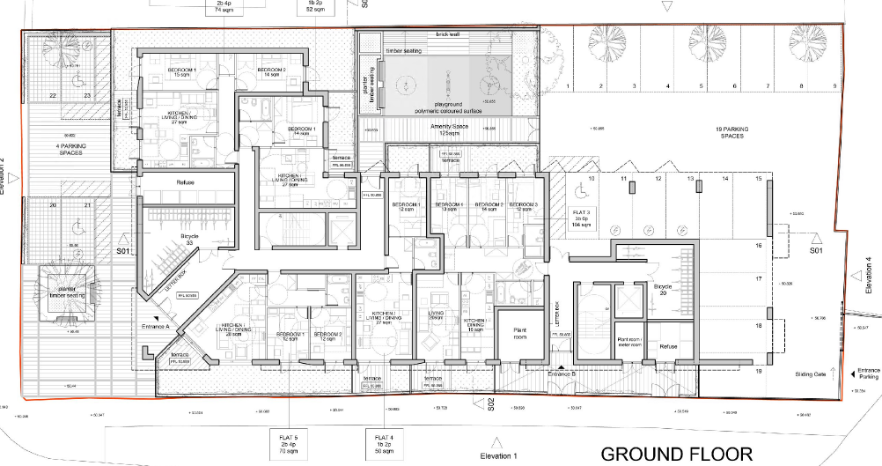

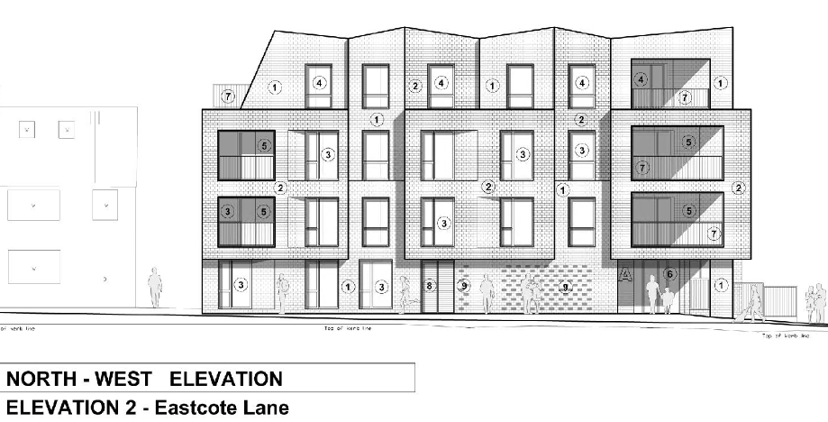
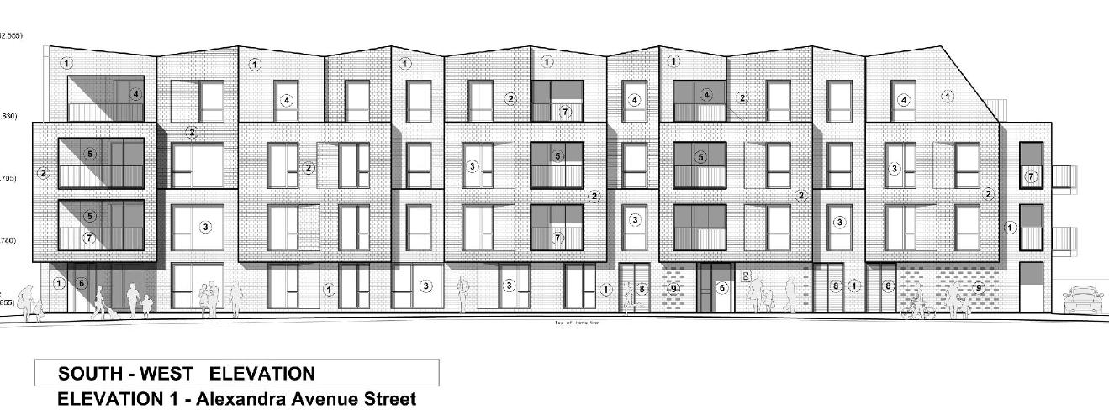

P/2156/19

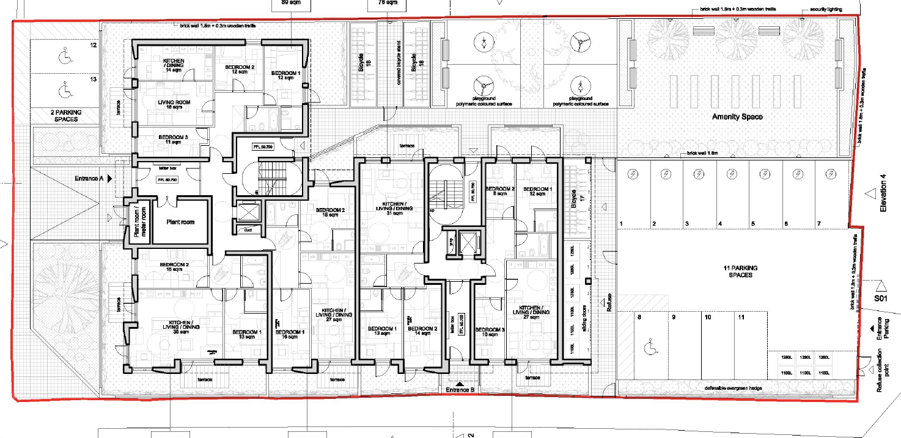

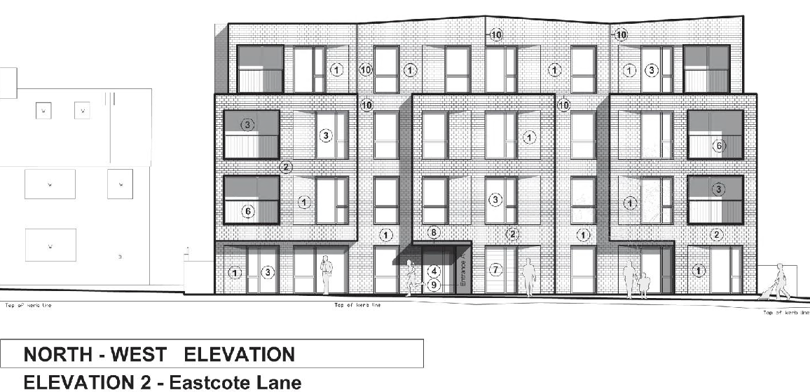

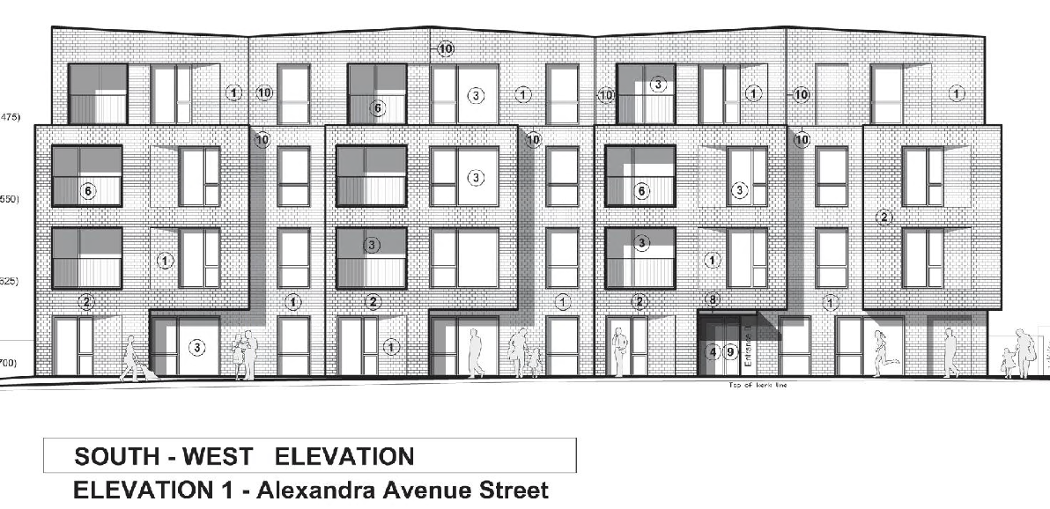
AGENDA ITEM 10 – REPRESENTATIONS ON PLANNING APPLICATIONS

Agenda Item |  | Application | Speakers
1/02 |  | 143-145 Eastcote Lane & 172 Alexandra Avenue | Councillor Jerry Miles (Back Bench)
2/02 |  | 2 Snaresbrook Drive, Stanmore, HA7 4QW | Jack Silverstone (Objector)  The agent was informed but has elected not to appear.

Whether the overhang constituted footprint was a point of contention at the Planning Appeal. Although The Planning Inspectorate did not provide a view on this specific matter, the original scheme was deemed Garden Land.

